Shortest Path Finder Using Dijkstra’s Algorithm

- Introduction
The Shortest Path Finder is a Python-based project that finds the shortest route between two locations in a weighted graph.
For example, imagine that a person wants to travel from City A to City D. There may be several possible routes, but each route has a different distance.
The program calculates the shortest route and its total distance using Dijkstra’s Algorithm.
This project represents locations as vertices and roads as edges. Each edge has a weight representing the distance between two locations.
- Objectives
- Find the shortest path between a starting location and a destination.
- Calculate the minimum total distance.
- Understand graphs and weighted edges.
- Implement Dijkstra’s Algorithm using Python.
- Display the selected route and its distance.
- Demonstrate a real-world application of ADSAA.
- Basic concepts
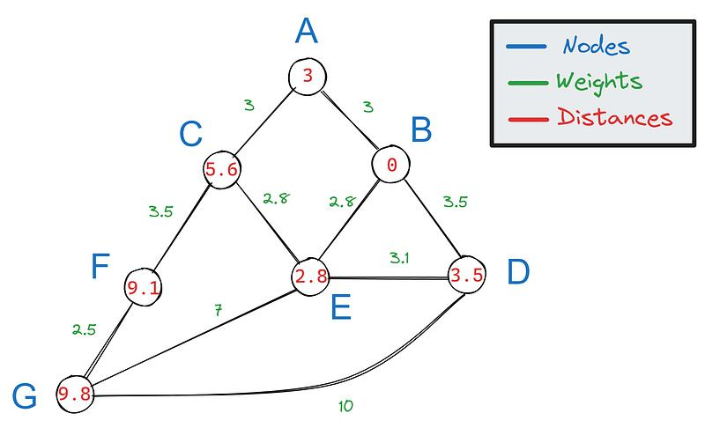

A. Graph
A graph consists of vertices and edges. In this project, vertices represent cities or locations, and edges represent roads connecting them.
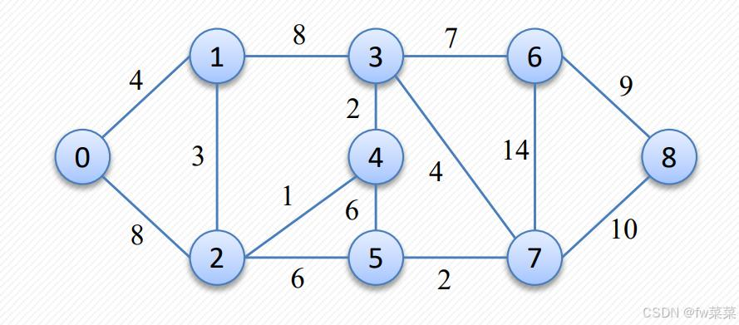
B. Weighted graph
Each edge has a numerical weight, such as distance in kilometres. For example, A to B may have a distance of 4 km.
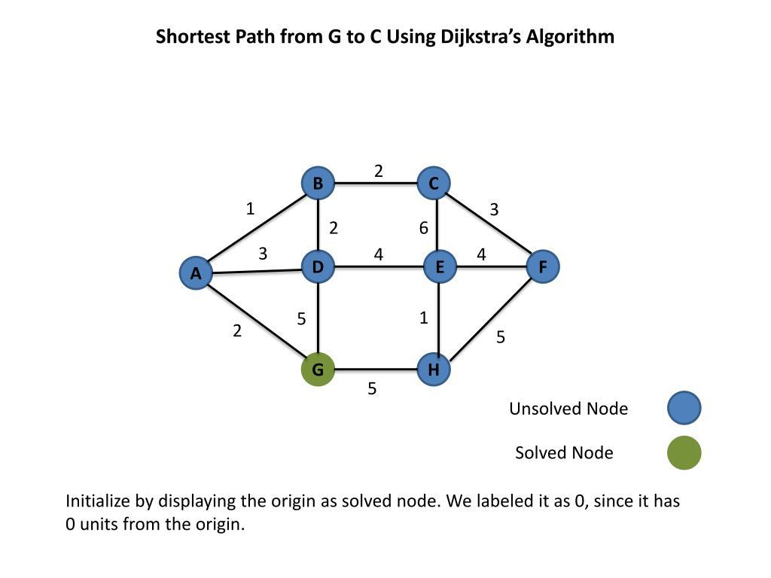

C. Shortest path
A path with the smallest total edge weight between the starting point and destination. It does not necessarily mean the path with the fewest roads.
Example graph:
Consider these five locations: A, B, C, D and E.
Weighted graph
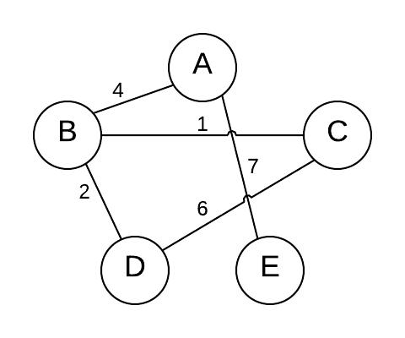
The numbers on the edges represent distances. Suppose we want to travel from A to D.
There are multiple possible routes:
Route | Calculation | Total distance
A → B → D | 4 + 5 | 9
A → C → D | 2 + 8 | 10
A → C → B → D | 2 + 1 + 5 | 8
The shortest route is:
A → C → B → D
Total distance = 2+1+5=8km.
Dijkstra’s Algorithm finds this minimum-distance route.

- What is Dijkstra’s Algorithm?
Dijkstra’s Algorithm is a Greedy Algorithm used to find the shortest distance from one starting vertex to other vertices in a weighted graph.
It repeatedly selects the unvisited vertex with the smallest known distance and updates the distances to its neighbouring vertices.
Algorithm steps
- Start with the source vertex A.
- Set the distance of A to 0 and all other vertices to infinity.
- Select the unvisited vertex with the smallest distance.
- Check its neighbouring vertices.
- Update a neighbour’s distance if a shorter route is found.
- Repeat until the destination is reached or no reachable vertices remain.
- Display the shortest route and its total distance.
Simple example
Suppose the current distance to B is 4 km, and the distance from B to D is 5 km.
The distance through B is: 4+5=9km
Later, if the program discovers a route of 8 km, it replaces the previous distance of 9 km with 8 km.
Important: Dijkstra’s Algorithm works correctly when all edge weights are non-negative.
- Explanation of the code
Code | Explanation
graph | Stores the locations, neighbours and distances.
distances | Stores the shortest distance found so far for each location.
previous | Remembers the previous location to reconstruct the shortest route.
heapq | Helps select the location with the smallest distance efficiently.
priority_queue | Stores locations waiting to be processed, ordered by distance.
new_distance | Calculates the distance through the current location.
If new_distance < distances[neighbour] | Updates the distance when a shorter route is found.
path.reverse() | Reverses the reconstructed route into source-to-destination order.
- Sample output
For input A as the starting location and D as the destination:
Available locations: A, B, C, D, E
Enter starting location: A
Enter destination: D
Shortest path: A -> C -> B -> D
Total distance: 8 km
Try other inputs, such as A to E or B to D, to test different routes.
- Time and space complexity
For this implementation using an adjacency list and a priority queue:
- Time complexity: (O((V+E)log V)) for a graph with (V) vertices and (E) edges.
- Space complexity: (O(V+E)), including the graph and supporting data structures.
- Real-time applications
- GPS navigation systems.
- Finding shortest routes between cities.
- Network packet routing.
- Robot path planning.
- Delivery route planning.
- Finding routes through connected locations in a game.
- Future enhancements
You can improve this basic project by adding:
- A graphical interface where users select locations.
- A visual graph showing the selected shortest route.
- User-defined locations and distances.
- A comparison of Dijkstra’s Algorithm with Bellman–Ford.
- Map-based location data.

